USE CASE DIAGRAMS

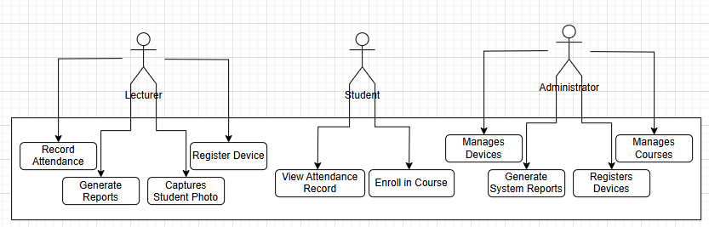TEAM BURDANGBALL

PROJECT X ATTENDANCE SYSTEM

MARK STUDENT ATTENDANCE

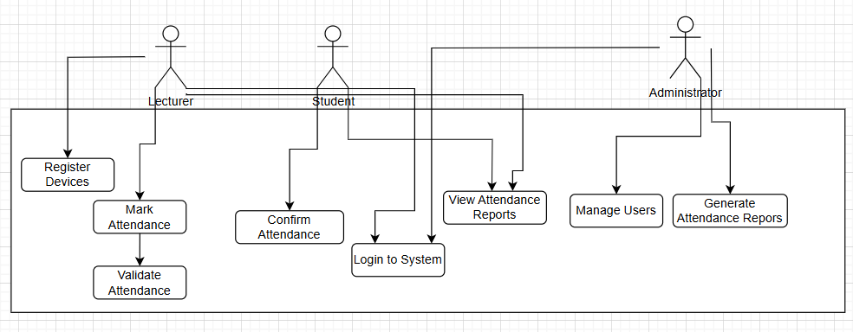GENERATE ATTENDANCE REPORT

